Textbook errors from Math 234

P27 I guess this is a typo. It should not be the derivative of vector v.

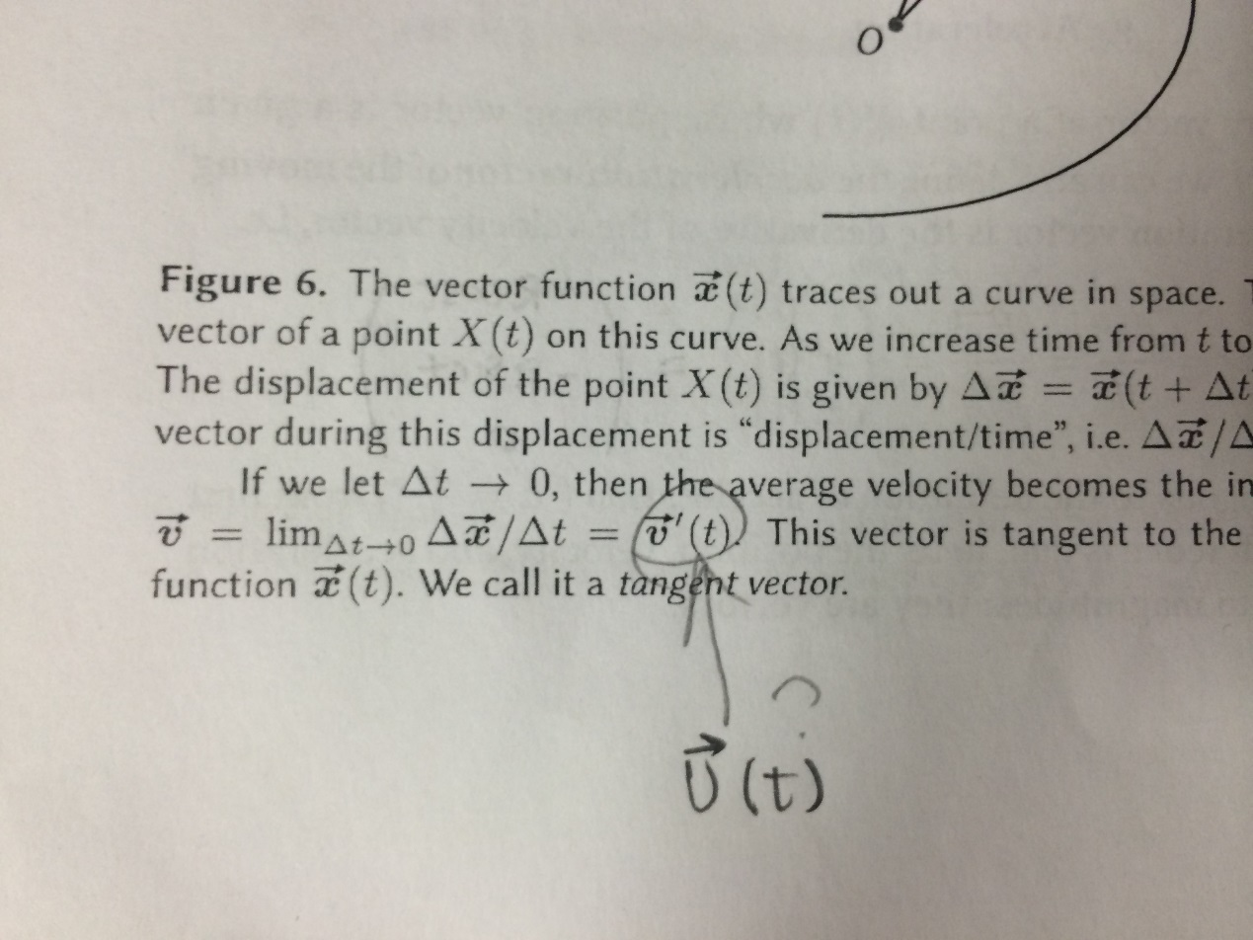

P43 There are only three special cases discussed below.

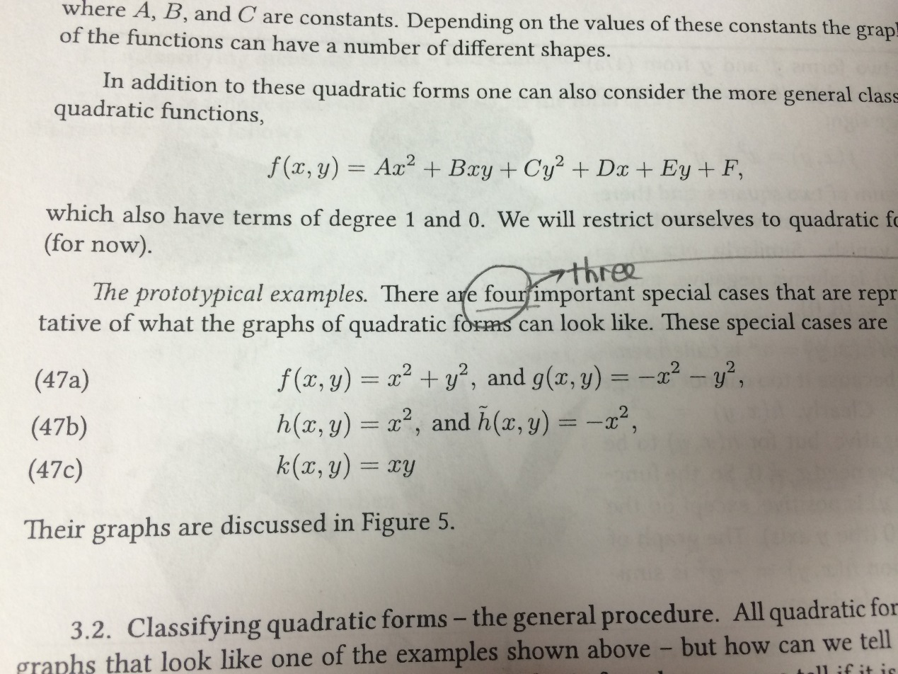

P56 It should be “Compute the partial derivatives of r.”

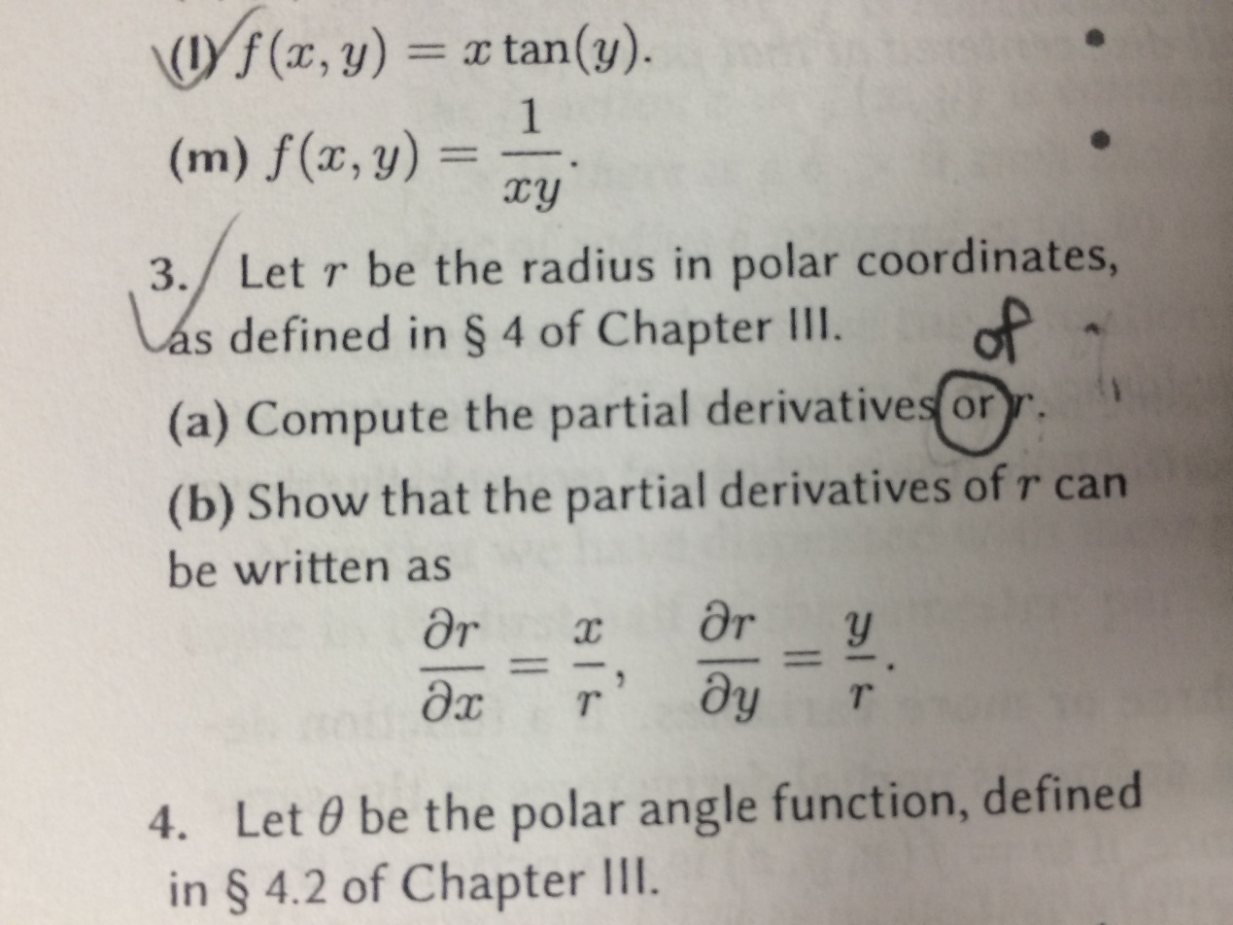

P104 The function given does not work. Instead, f(x,y)=x3-3xy2 works.

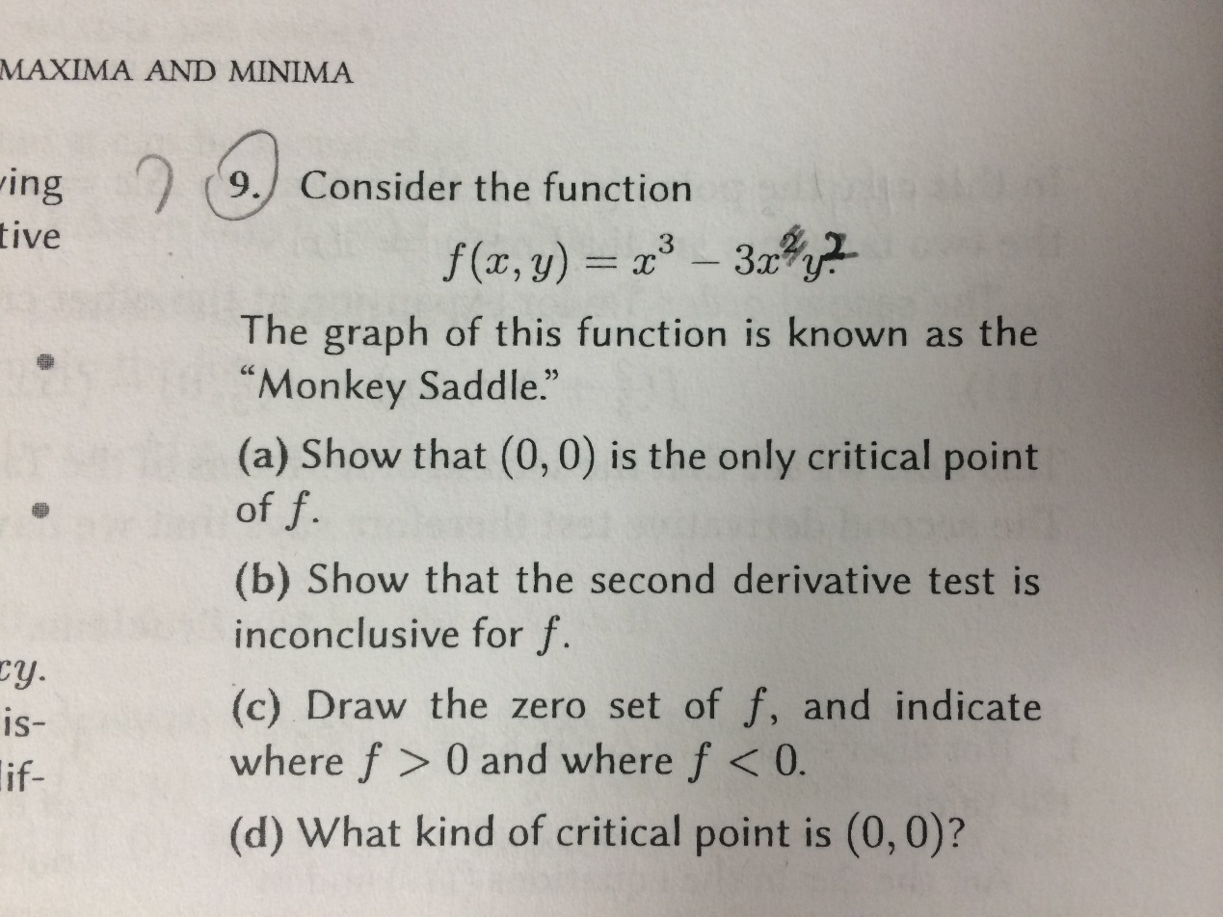P115 The domain for 2.4 Theorem: an “x” is needed, instead of b

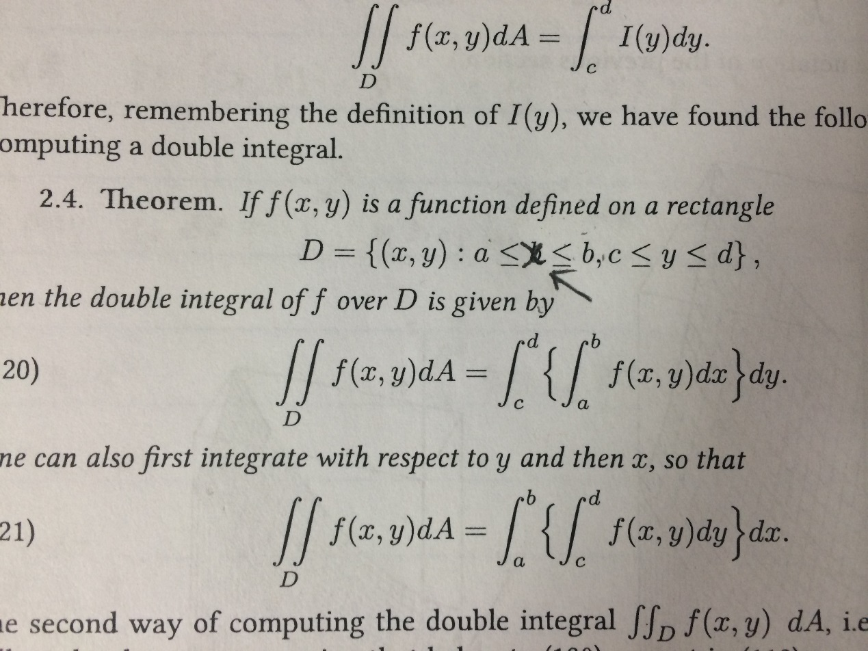

P170 The definition of curl given is not correct.

